ANALYZING THE PERFORMANCE AND EFFICIENCY OF THE RADISSON HOTELS USING DATA VISUALIZATION TECHNIQUES

INTRODUCTION:

1.1 OVERVIEW

Radisson owns multiple five-star hotels across India. They have been in the hospitality industry for the past 100 years. Due to strategic moves from the other competitors and ineffective decision-making in management, Radisson is losing its market share and revenue in the luxury/business hotels category. As a strategic move, the managing director of Radisson wanted to incorporte Business and Data intelligence in order to regain their market share and revenue. Our task is to create an analytics dashboard and story to provide them insights to make better business decisions .

1.2 Purpose

As a result of this projects we can provide analytics dashboard and story to managing director. So the managing director able to incorporate Business and Data intelligence and he can regain their market share and revenue and also he can make better business decisions.

2 PROBELEM DEFINITION & DESIGN THINKING

2.1 Empathy Map

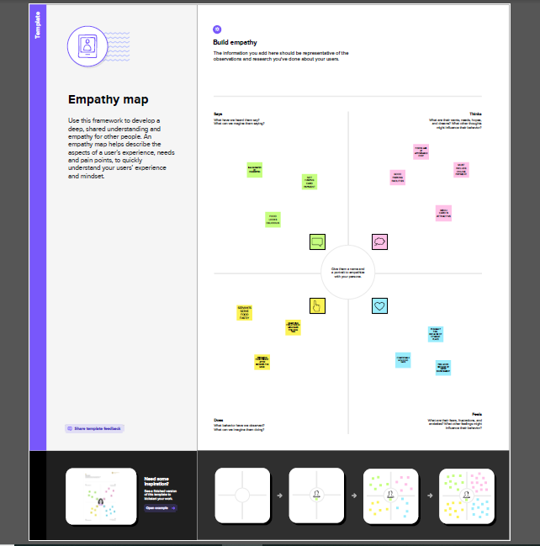

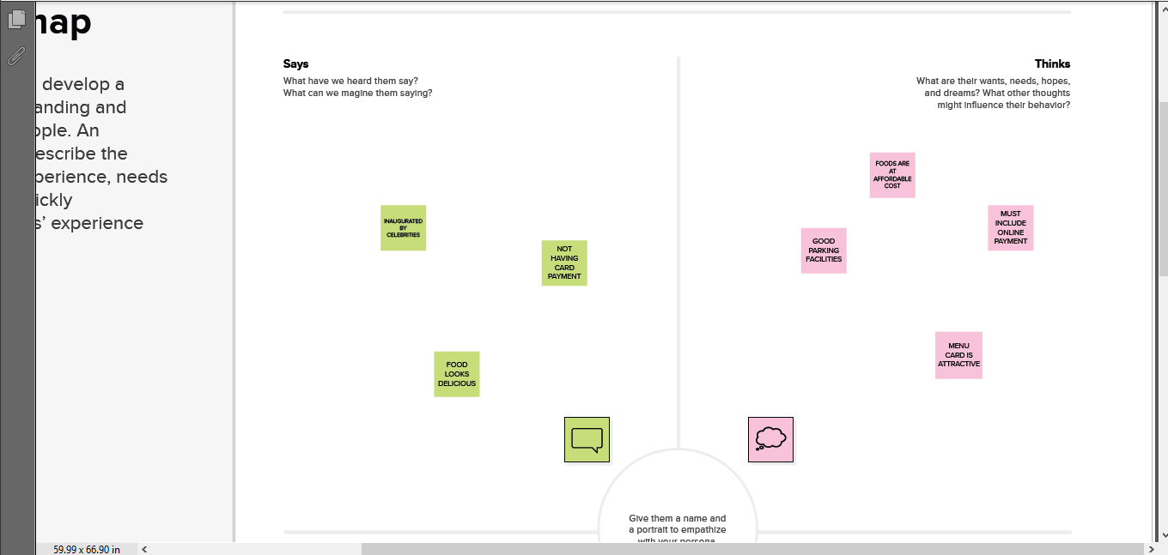

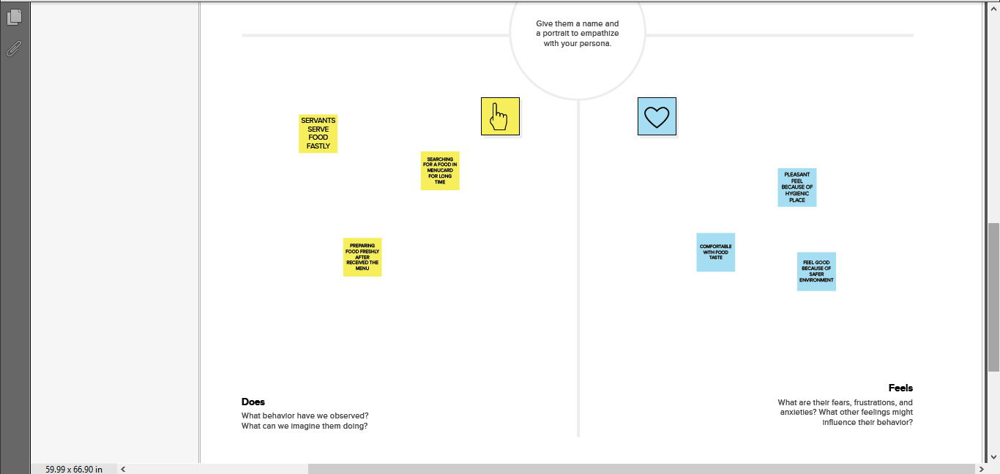

2.2 IDEATION AND BRAINSTORMING

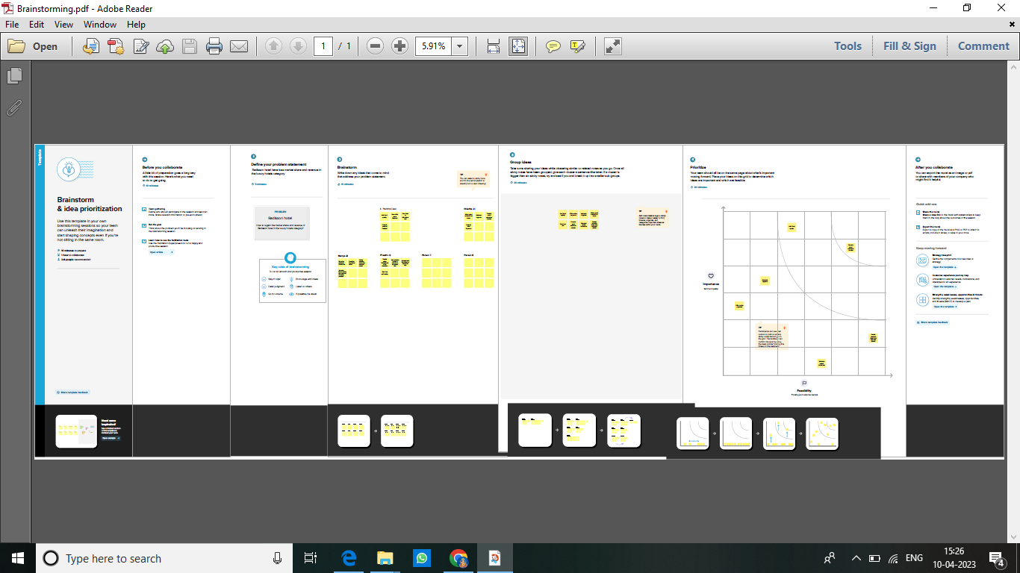

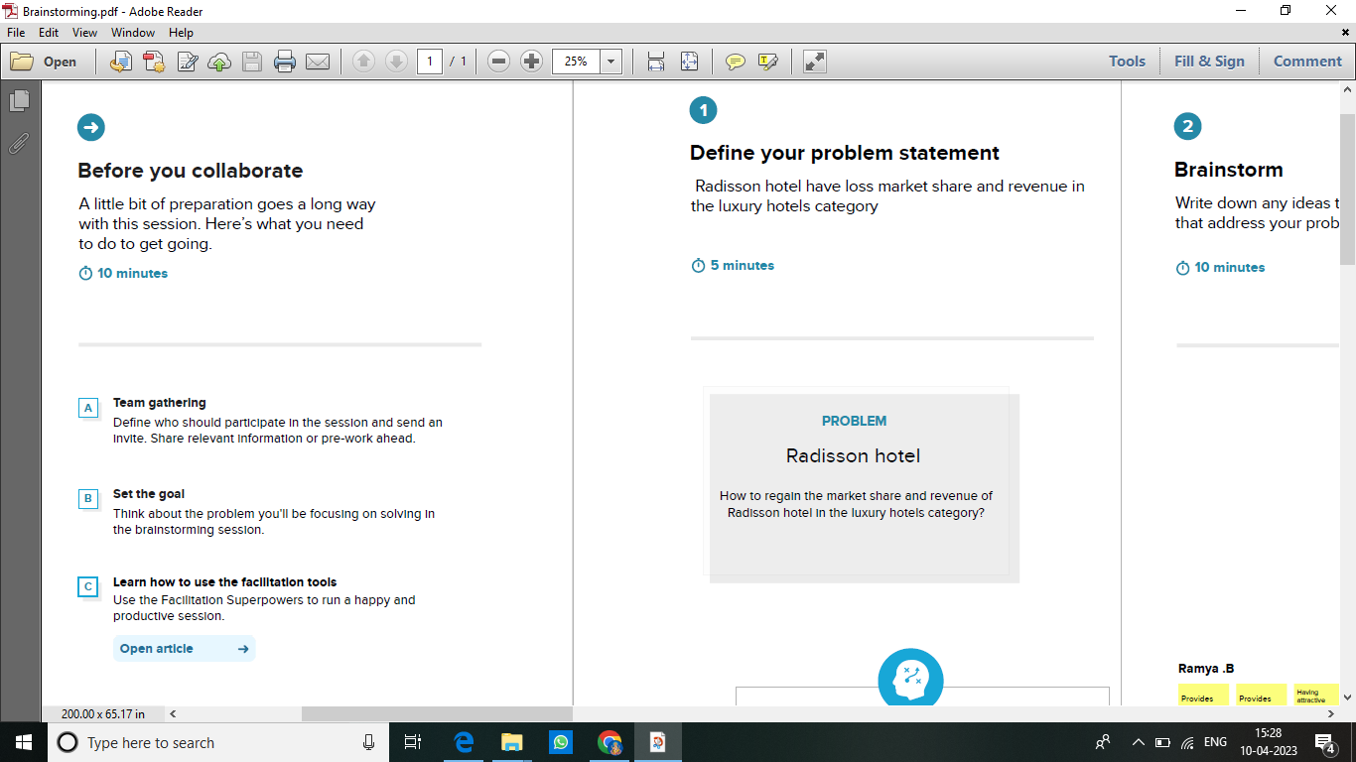

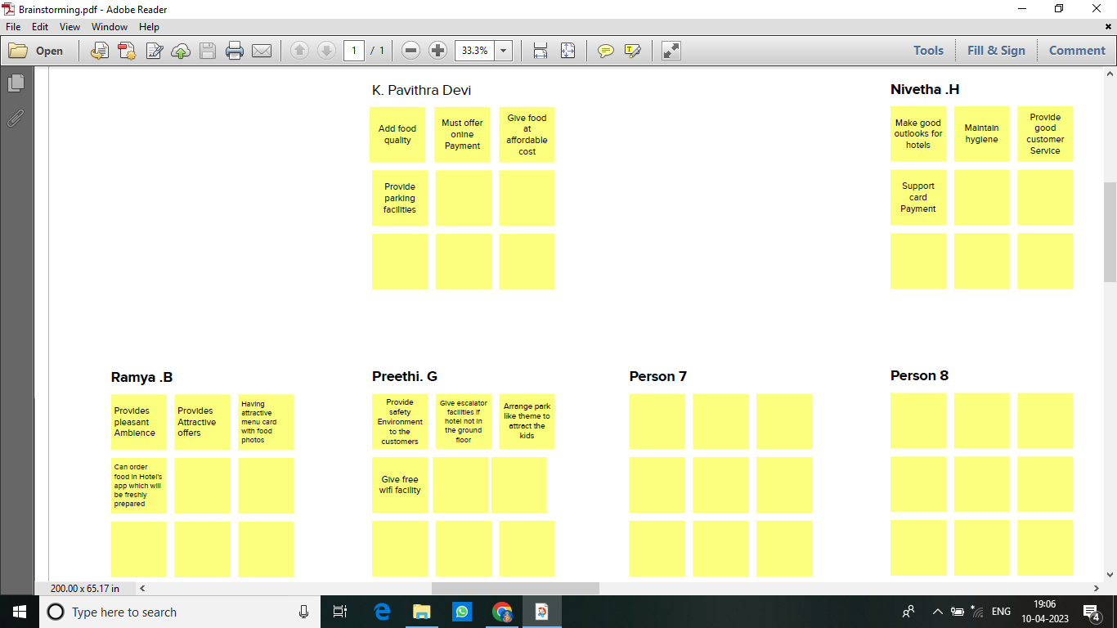

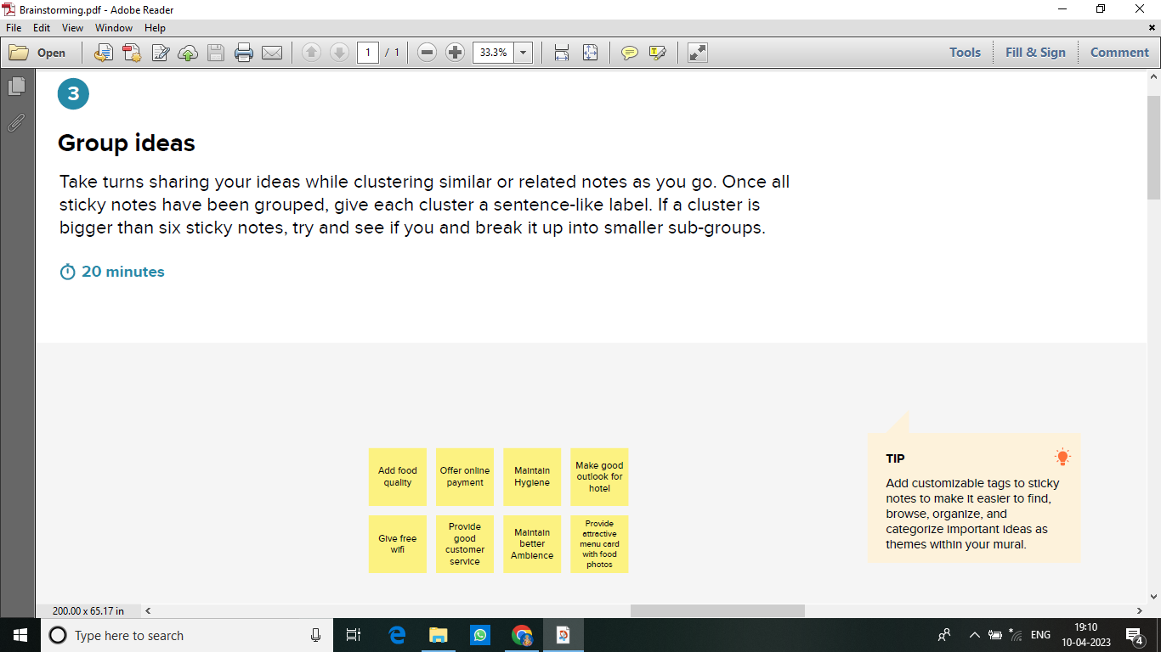

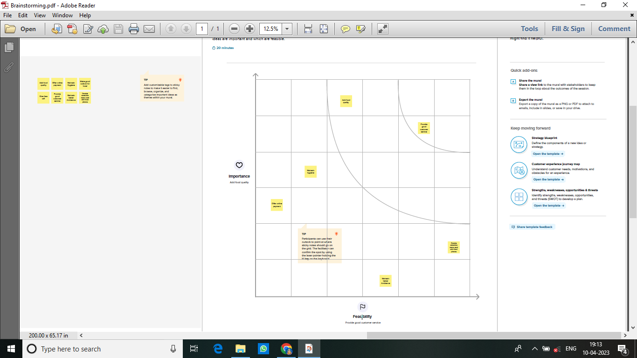

3 RESULT

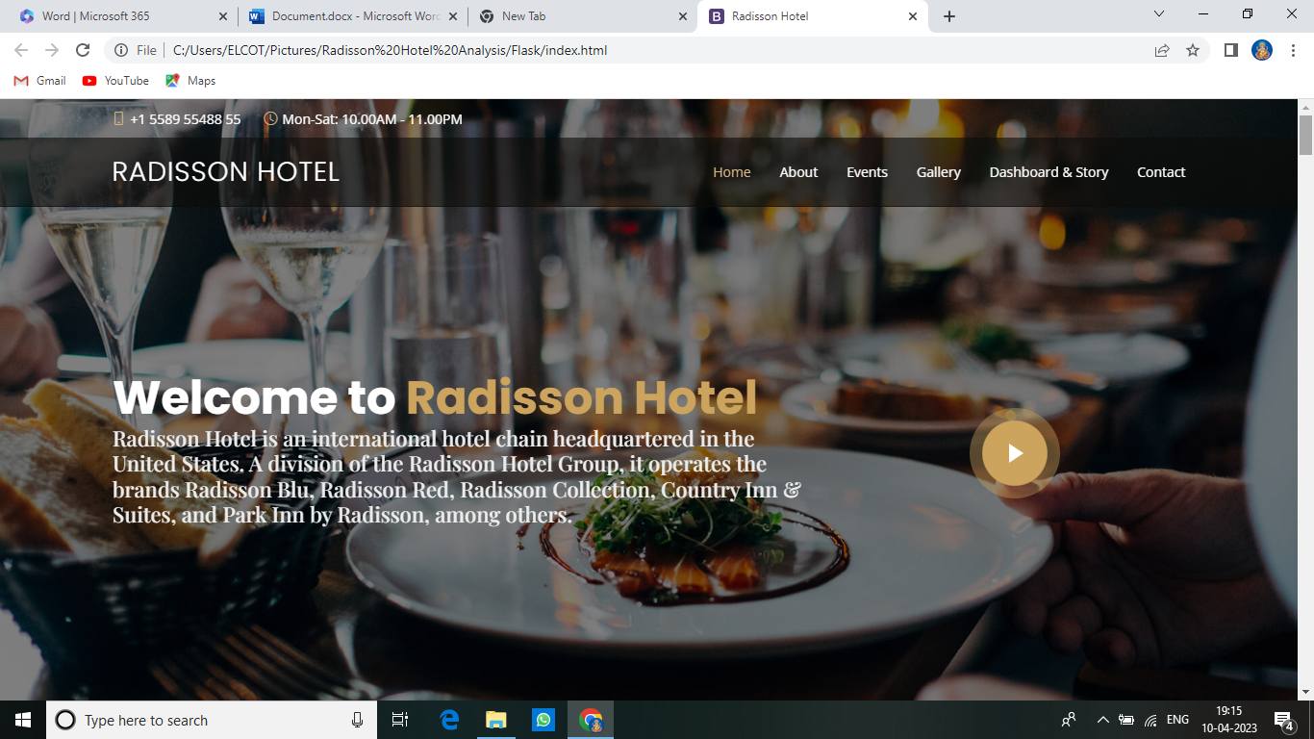

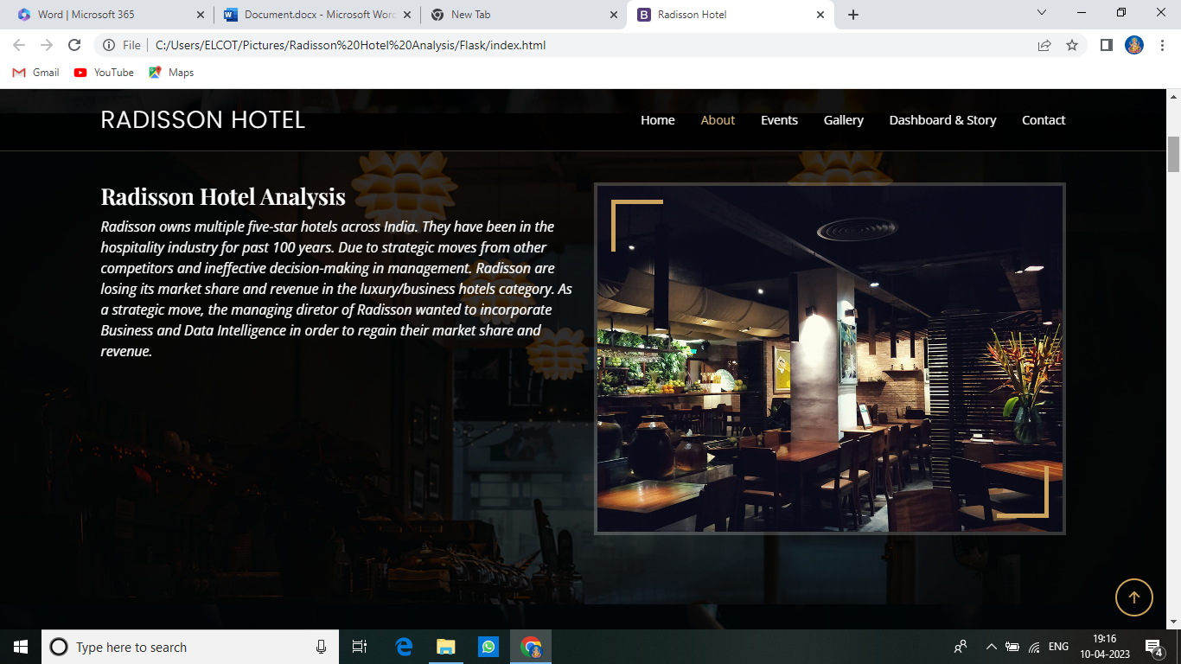

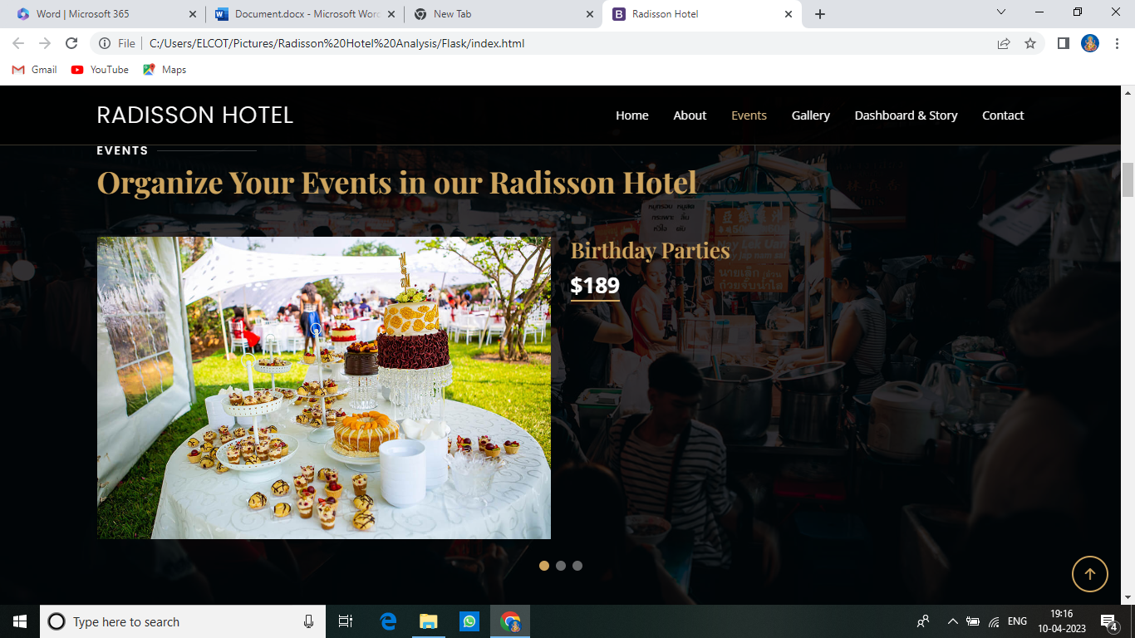

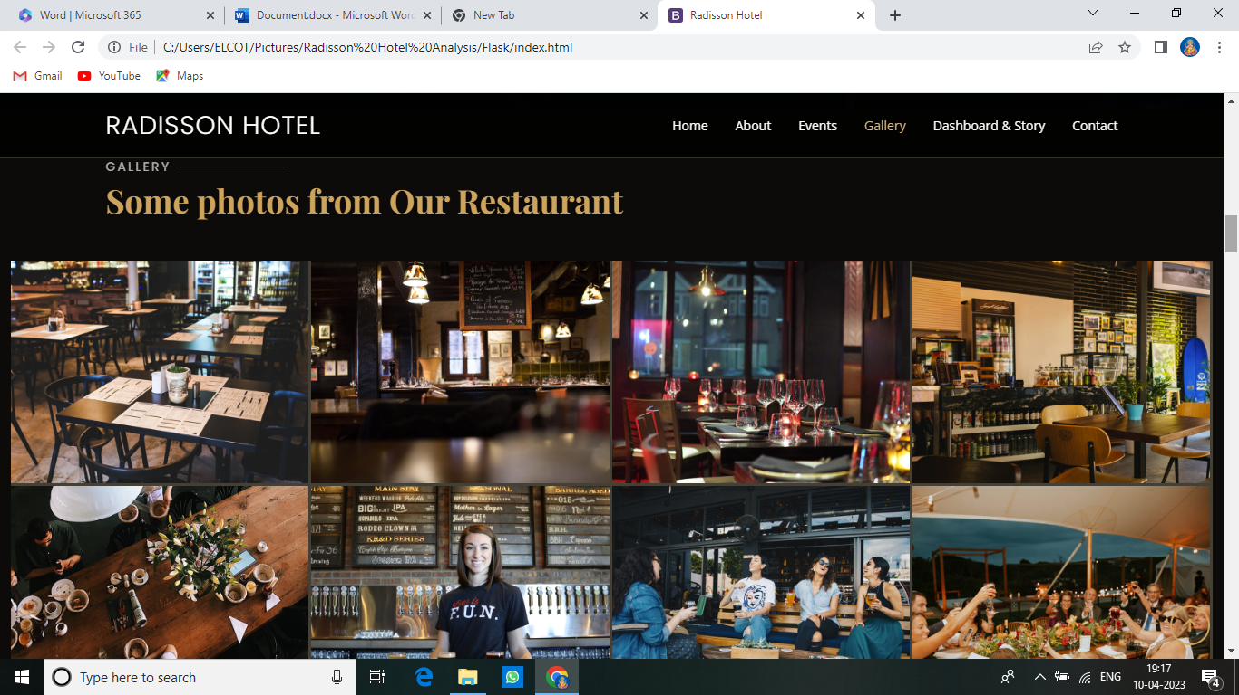

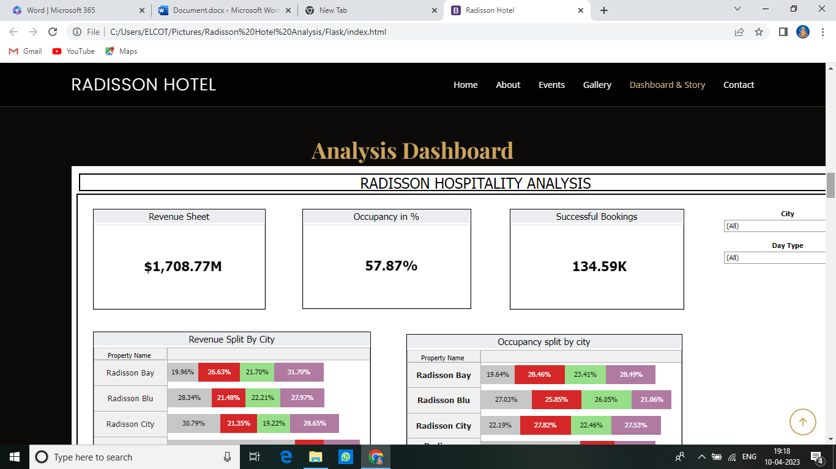

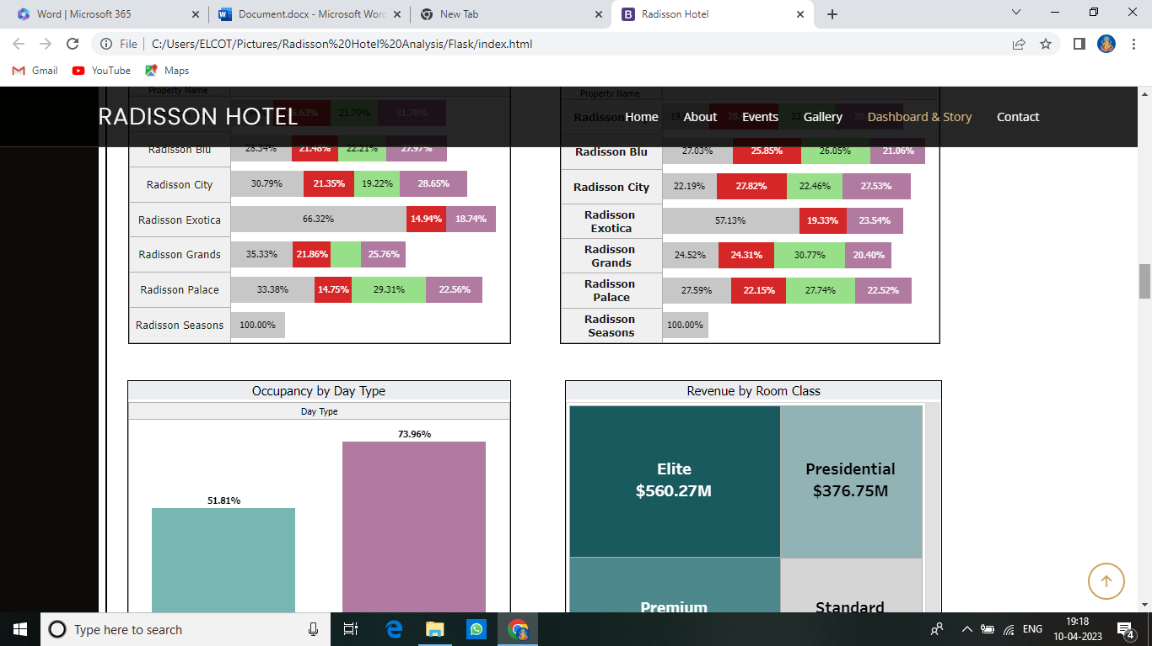

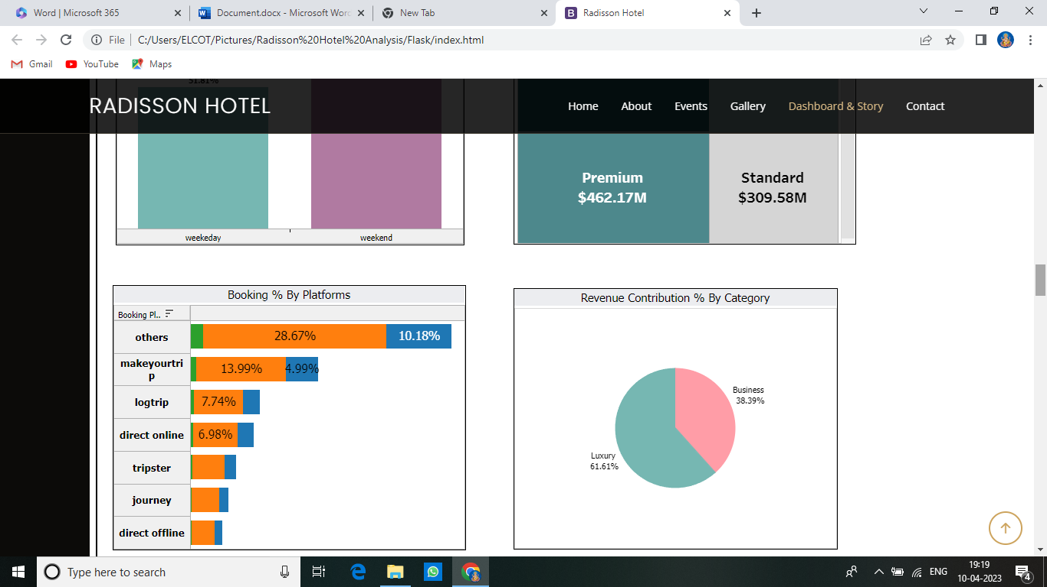

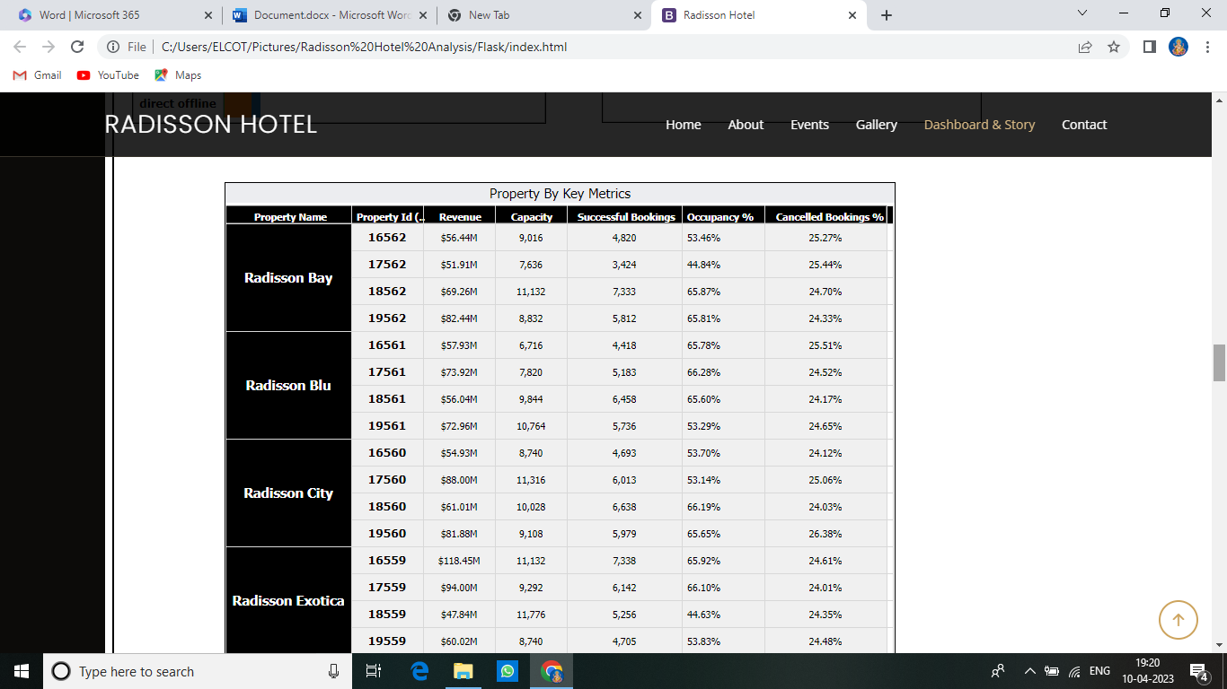

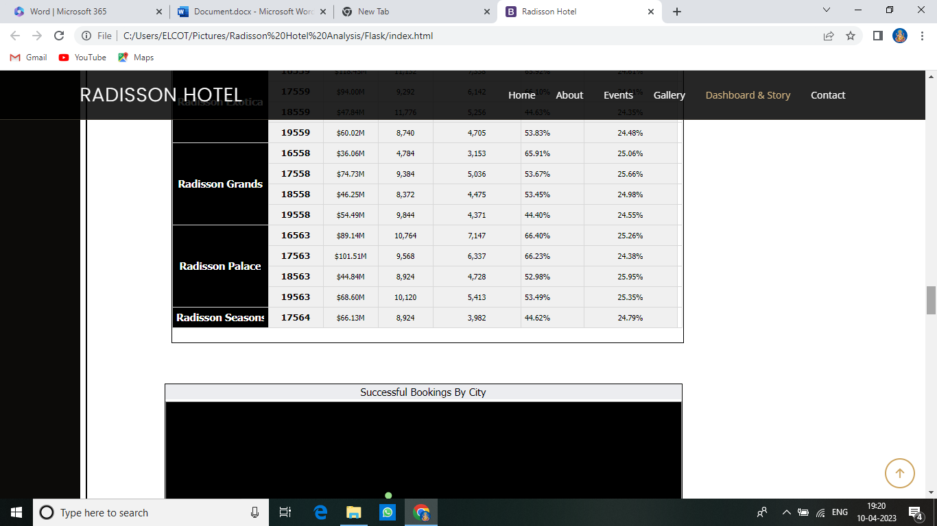

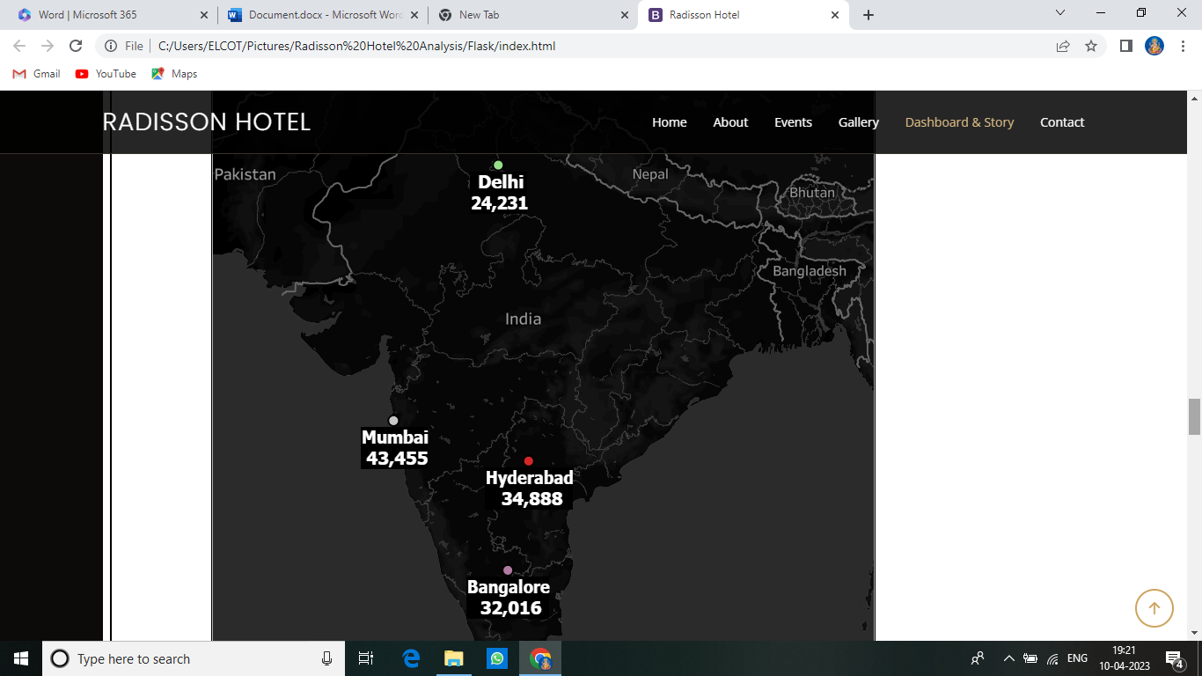

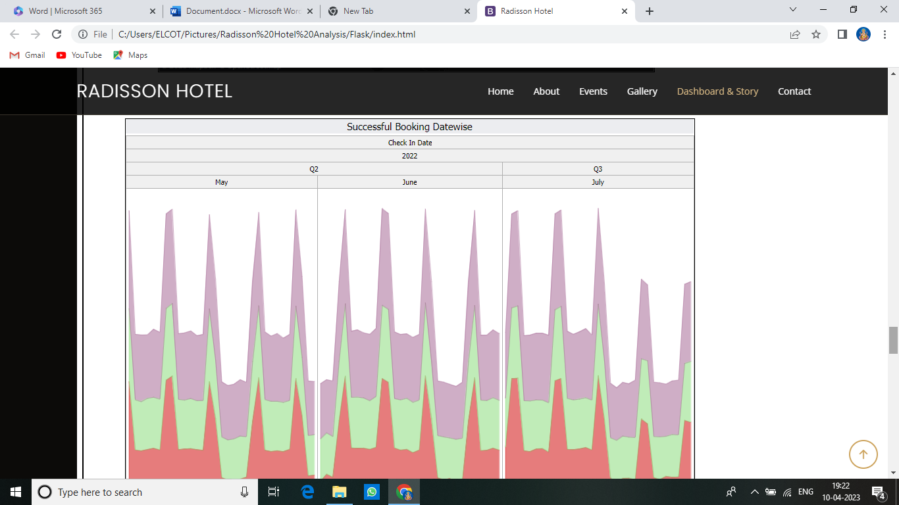

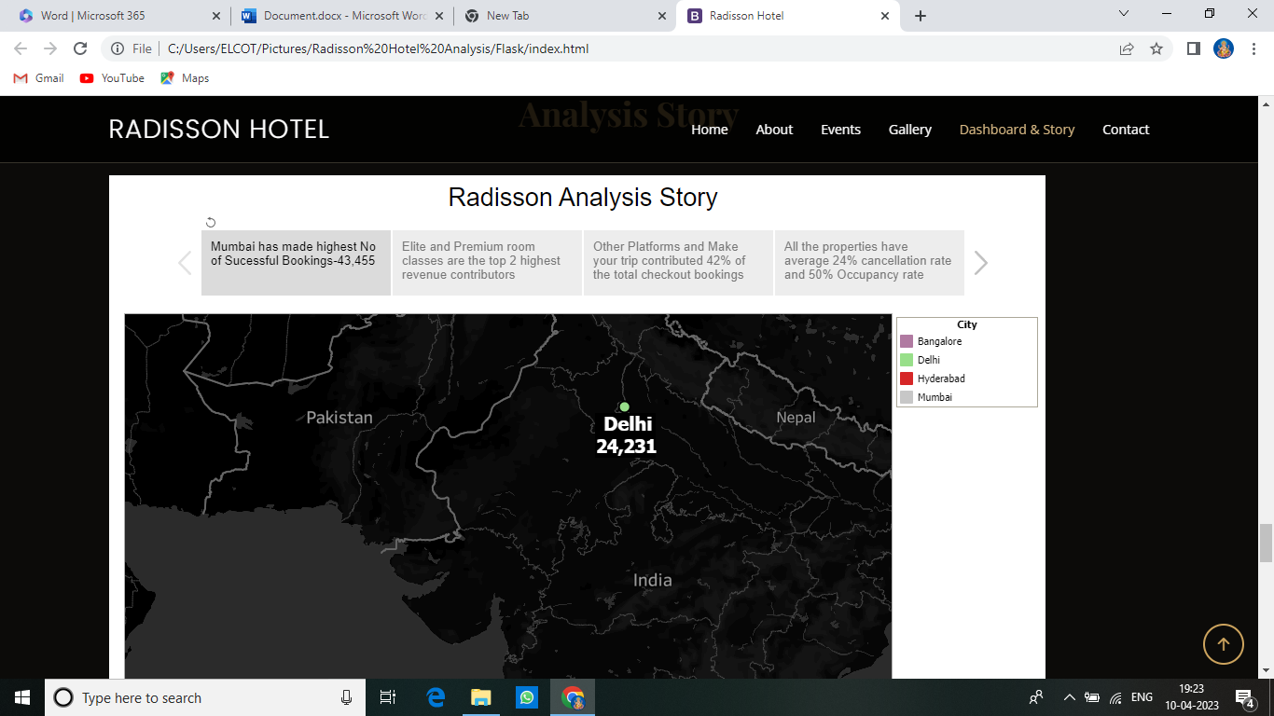

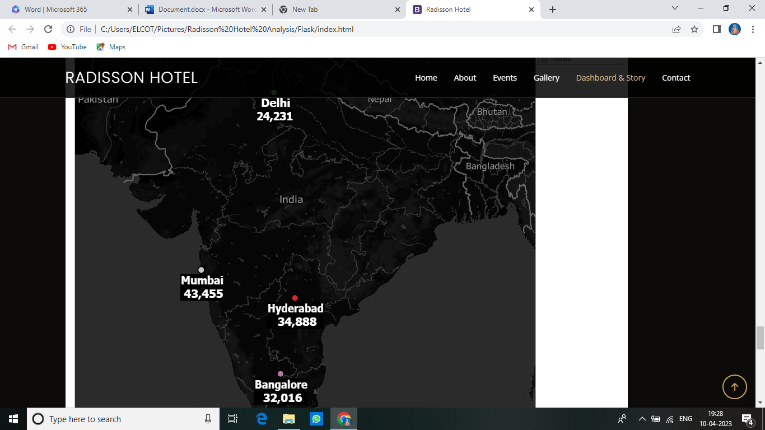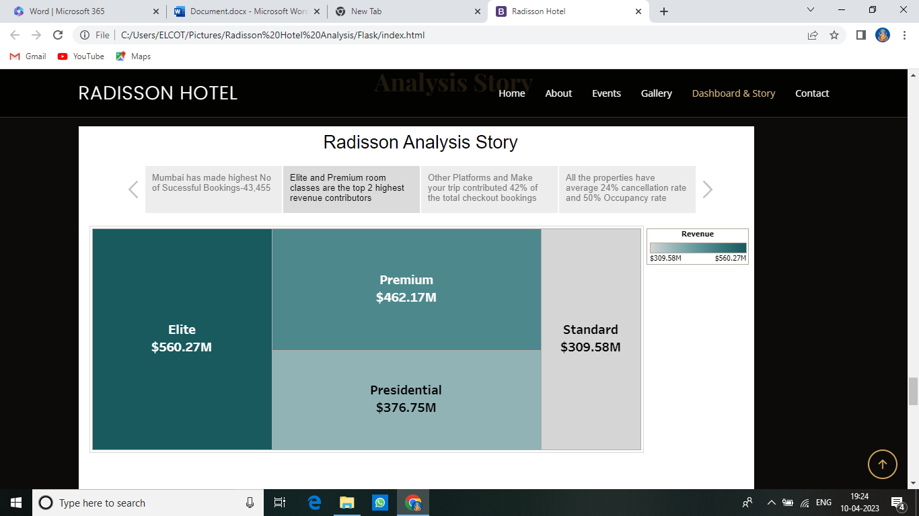

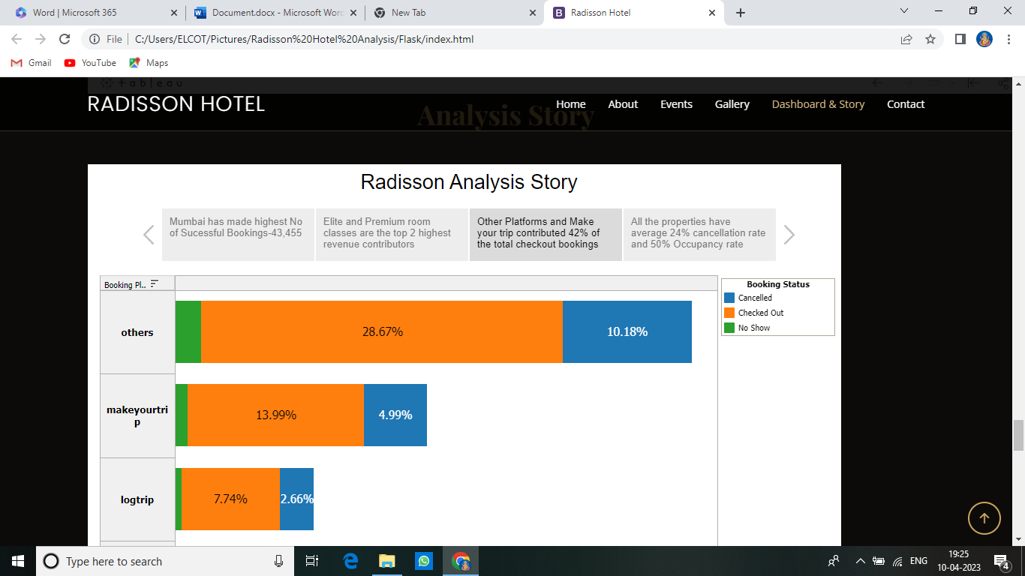

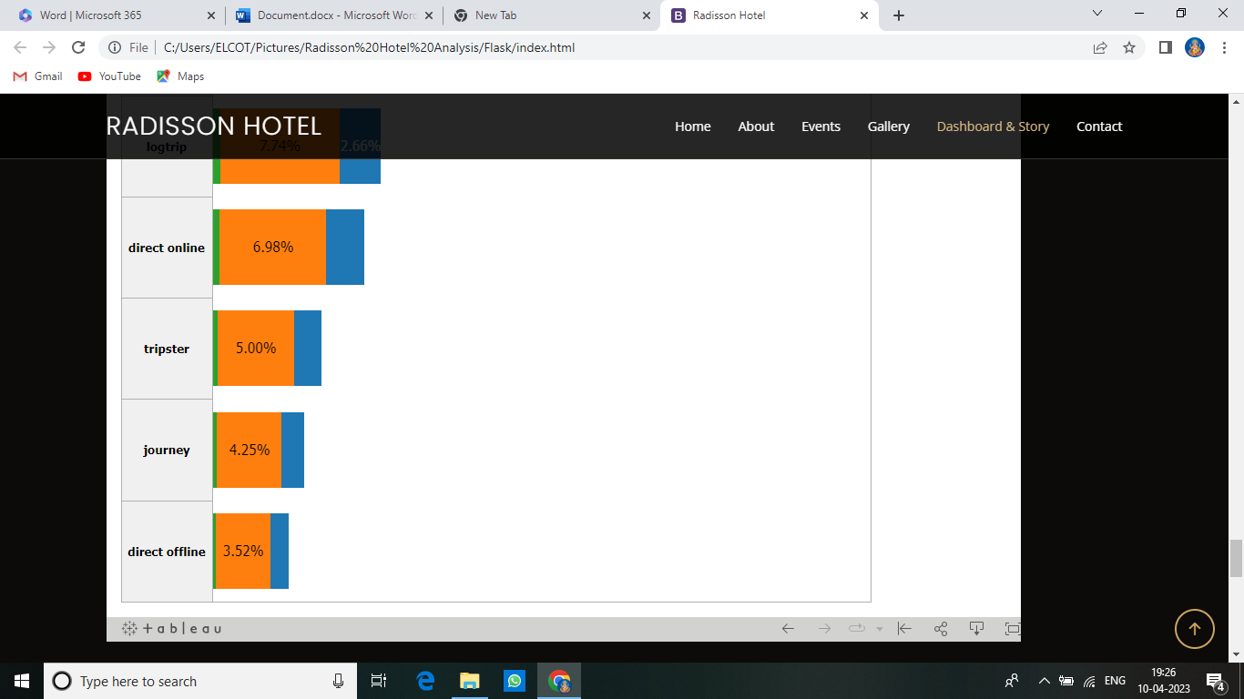

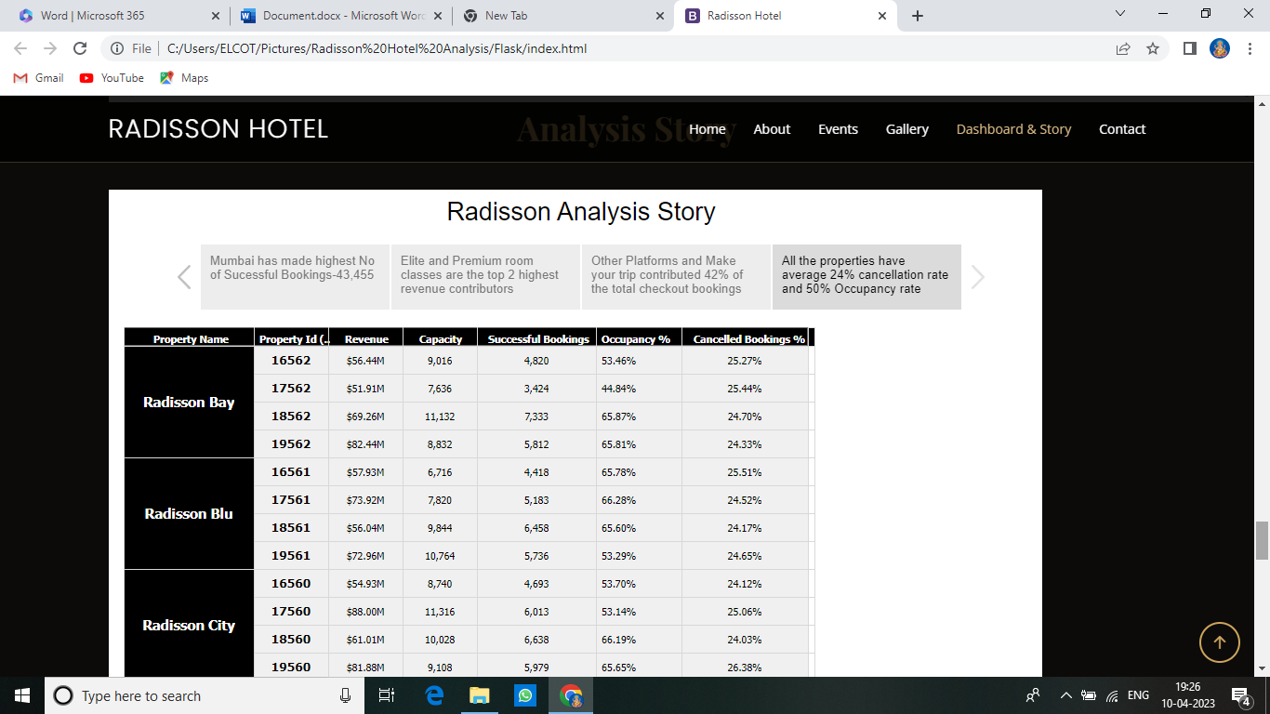

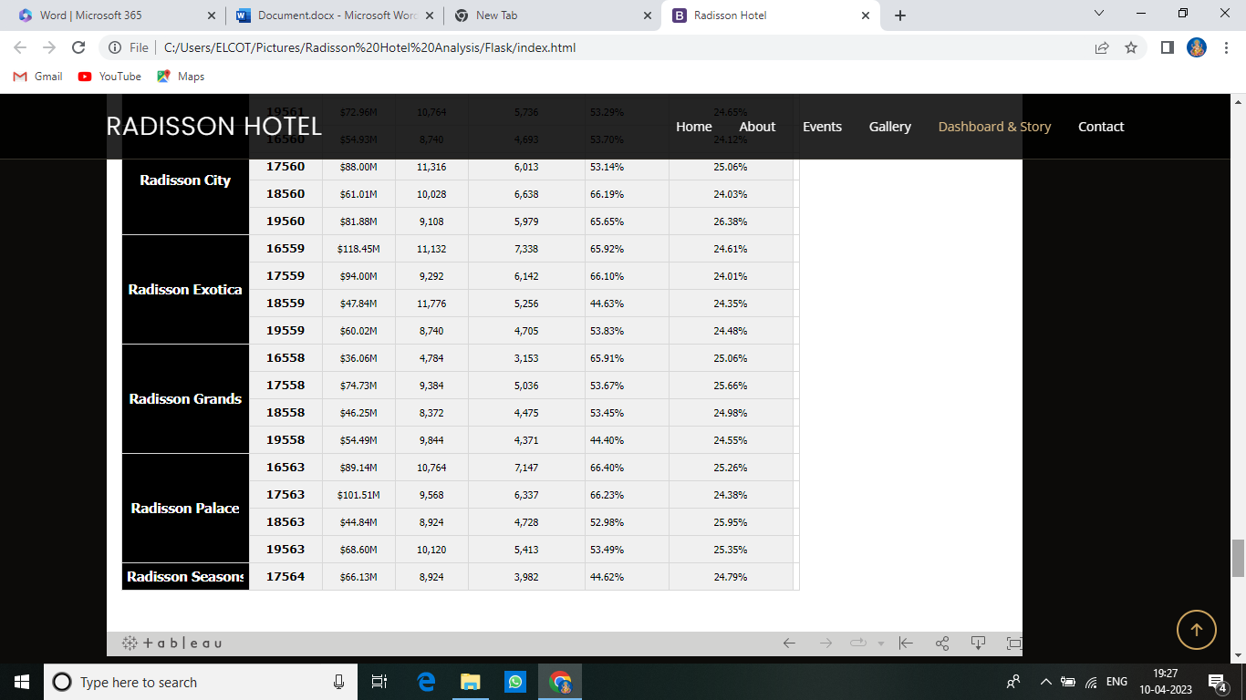

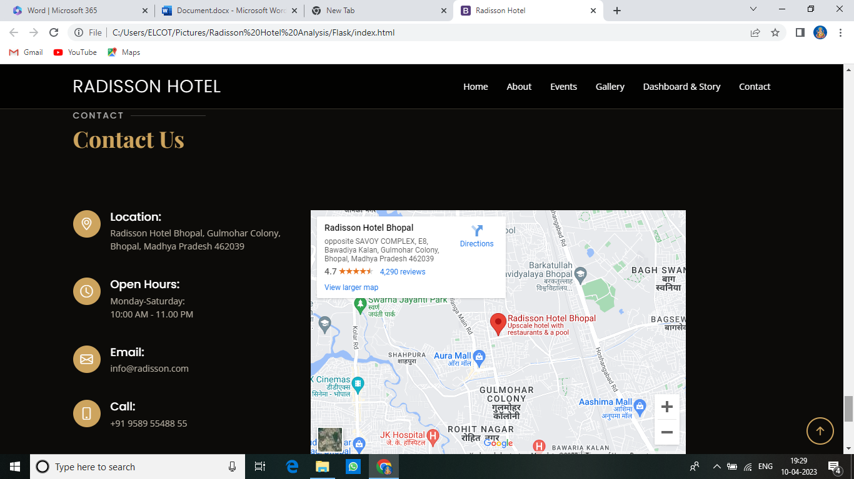

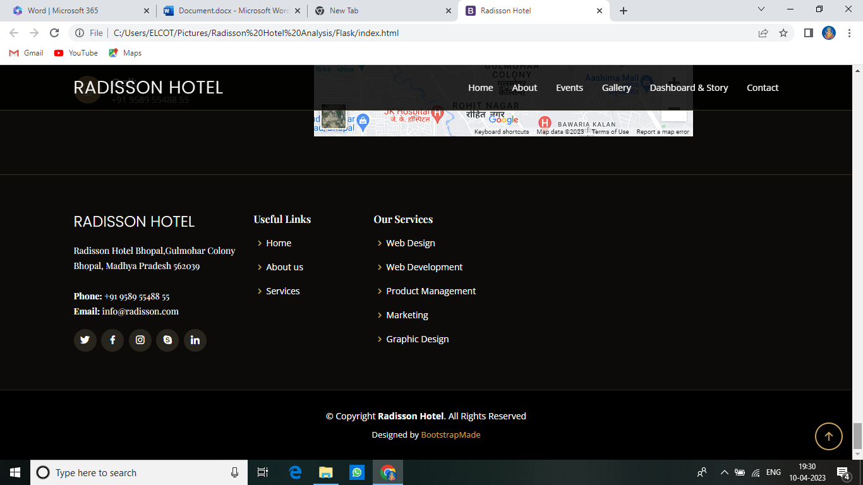

4 ADVANTAGES & DISADVANTAGES

ADVANTAGES:

By analysing performance data using data visualizations, decision-makers can quickly identify trends, patterns, and outliers that may not be immediately apparent in raw data. This information can help them make more informed decisions about areas that need improvement or investment.

By analysing performance data using visualizations, Radisson hotels can identify inefficiencies in their operations, allowing them to take corrective actions to improve overall efficiency.

Visualizations can help identify areas where the hotel is performing well or where there is potential for improvement. This information can be used to develop strategies to capitalize on opportunities and address areas of weakness.

DISADVANTAGES:

The accuracy and usefulness of the data visualization can be affected if the data used is biased or incomplete. If certain data points are missing or if the data is skewed towards certain areas or demographics, the resulting visualizations may not accurately represent the performance of the hotel.

Data visualization requires proper tools and technology to work effectively. If there are technical issues with the software or hardware used, the visualizations may not be accurate or may not even work at all.

Effective data visualization often requires significant investment in software, hardware, and training. For smaller hotels or those with limited resources, this may not be feasible.

5 APPLICATIONS

By analysing the occupancy rates of Radisson Hotels over time, hotel managers can identify when the hotel is as its busiest and plan staffing accordingly. Data visualization techniques such as line charts or heatmaps can be used to display this data in a clear and easy-to-understand way.

Radisson Hotels operate in multiple locations across the globe. By comparing the performance of each location, hotel managers can identify which locations are performing well and which ones require attention. Bar charts or scatterplots can be used to display this data.

Revenue is a key metric for any hotel, and by monitoring revenue trends over time, hotel managers can identify when revenue is growing or declining. Line charts or stacked bar charts can be used to display this data.

By analyzing operational costs such as labor or utilities, hotel managers can identify areas where cost savings can be made. Data visualization techniques such as pie charts or bar charts can be used to display this data.

Radisson Hotels collect customer feedback through various channels, such as online reviews or surveys. By analyzing this feedback using sentiment analysis techniques and displaying it using data visualizations tools such as word clouds or heatmaps, hotel managers can identify common issues or areas of improvement.

6 CONCLUSION

In my project we analysed the efficiency of Radisson hotel and I put data visualizations like revenue split by city, Occupancy Split by city and all. By these visualizations we can easily understand where we have to improve where we are lacking and all.

We put visualization by city-wise, Room-wise, Date-wise and all so it will be more helpful to manager to take good decisions.

By using the datas we put clear visualizations and we make dashboard and story so these things will help the manager to take good and effective decisions.

7 FUTURE SCOPE

Data visualization can be used to analyze trends in revenue over time and across different properties, helping hotel managers to identify areas where revenue can be increased and costs can be reduced.

By visualizing customer feedback data, hotel managers can gain insights into what customers like and dislike about their properties. This can help them to make changes that will improve the overall customer experience.

Data visualization can be used to analyze the effectiveness of different marketing and advertising campaigns, helping hotel managers to make more informed decisions about where to allocate resources.

By visualizing data related to hotel operations, managers can identify inefficiencies and areas where processes can be streamlined to reduce costs and improve guest experiences.

Data visualization can be used to analyze employee performance metrics, such as turnover rates, attendance, and productivity, helping hotel managers to identify areas where training and development may be needed.

8 APPENDIX

Source Code:

<!DOCTYPE html>

<html lang="en">

<head>

<meta charset="utf-8">

<meta content="width=device-width, initial-scale=1.0" name="viewport">

<title>Radisson Hotel</title>

<meta content="" name="description">

<meta content="" name="keywords">

<!-- Favicons -->

<link href="assets/img/favicon.png" rel="icon">

<link href="assets/img/apple-touch-icon.png" rel="apple-touch-icon">

<!-- Google Fonts -->

<link href="https://fonts.googleapis.com/css?family=Open+Sans:300,300i,400,400i,600,600i,700,700i|Playfair+Display:ital,wght@0,400;0,500;0,600;0,700;1,400;1,500;1,600;1,700|Poppins:300,300i,400,400i,500,500i,600,600i,700,700i" rel="stylesheet">

<!-- Vendor CSS Files -->

<link href="assets/vendor/animate.css/animate.min.css" rel="stylesheet">

<link href="assets/vendor/aos/aos.css" rel="stylesheet">

<link href="assets/vendor/bootstrap/css/bootstrap.min.css" rel="stylesheet">

<link href="assets/vendor/bootstrap-icons/bootstrap-icons.css" rel="stylesheet">

<link href="assets/vendor/boxicons/css/boxicons.min.css" rel="stylesheet">

<link href="assets/vendor/glightbox/css/glightbox.min.css" rel="stylesheet">

<link href="assets/vendor/swiper/swiper-bundle.min.css" rel="stylesheet">

<!-- Template Main CSS File -->

<link href="assets/css/style.css" rel="stylesheet">

<!-- =======================================================

* Template Name: Restaurantly

* Updated: Mar 10 2023 with Bootstrap v5.2.3

* Template URL: <https://bootstrapmade.com/restaurantly-restaurant-template/>

* Author: BootstrapMade.com

* License: <https://bootstrapmade.com/license/>

======================================================== -->

</head>

<body>

<!-- ======= Top Bar ======= -->

<div id="topbar" class="d-flex align-items-center fixed-top">

<div class="container d-flex justify-content-center justify-content-md-between">

<div class="contact-info d-flex align-items-center">

<i class="bi bi-phone d-flex align-items-center"><span>+1 5589 55488 55</span></i>

<i class="bi bi-clock d-flex align-items-center ms-4"><span> Mon-Sat: 10.00AM - 11.00PM</span></i>

</div>

</div>

</div>

<!-- ======= Header ======= -->

<header id="header" class="fixed-top d-flex align-items-cente">

<div class="container-fluid container-xl d-flex align-items-center justify-content-lg-between">

<h1 class="logo me-auto me-lg-0"><a href="index.html">Radisson Hotel</a></h1>

<!-- Uncomment below if you prefer to use an image logo -->

<!-- <a href="index.html" class="logo me-auto me-lg-0"><img src="assets/img/logo.png" alt="" class="img-fluid"></a>-->

<nav id="navbar" class="navbar order-last order-lg-0">

<ul>

<li><a class="nav-link scrollto active" href="#hero">Home</a></li>

<li><a class="nav-link scrollto" href="#about">About</a></li>

<li><a class="nav-link scrollto" href="#events">Events</a></li>

<li><a class="nav-link scrollto" href="#gallery">Gallery</a></li>

<li><a class="nav-link scrollto" href="#chefs">Dashboard & Story</a></li>

<li><a class="nav-link scrollto" href="contact">Contact</a></li>

</ul>

<i class="bi bi-list mobile-nav-toggle"></i>

</nav><!-- .navbar -->

</div>

</header><!-- End Header -->

<!-- ======= Hero Section ======= -->

<section id="hero" class="d-flex align-items-center">

<div class="container position-relative text-center text-lg-start" data-aos="zoom-in" data-aos-delay="100">

<div class="row">

<div class="col-lg-8">

<h1>Welcome to <span>Radisson Hotel</span></h1>

<h2>Radisson Hotel is an international hotel chain headquartered in the United States. A division of the Radisson Hotel Group, it operates the brands Radisson Blu, Radisson Red, Radisson Collection, Country Inn & Suites, and Park Inn by Radisson, among others.</h2>

</div>

<div class="col-lg-4 d-flex align-items-center justify-content-center position-relative" data-aos="zoom-in" data-aos-delay="200">

<a href="https://www.youtube.com/watch?v=u6BOC7CDUTQ" class="glightbox play-btn"></a>

</div>

</div>

</div>

</section><!-- End Hero -->

<main id="main">

<!-- ======= About Section ======= -->

<section id="about" class="about">

<div class="container" data-aos="fade-up">

<div class="row">

<div class="col-lg-6 order-1 order-lg-2" data-aos="zoom-in" data-aos-delay="100">

<div class="about-img">

<img src="assets/img/about.jpg" alt="">

</div>

</div>

<div class="col-lg-6 pt-4 pt-lg-0 order-2 order-lg-1 content">

<h3>Radisson Hotel Analysis</h3>

<p class="fst-italic">

Radisson owns multiple five-star hotels across India. They have been in the hospitality industry for past 100 years. Due to strategic moves from other competitors and ineffective decision-making in management. Radisson are losing its market share and revenue in the luxury/business hotels category. As a strategic move, the managing diretor of Radisson wanted to incorporate Business and Data Intelligence in order to regain their market share and revenue.

<p>

</p>

</div>

</div>

</div>

</section><!-- End About Section -->

<!-- ======= Events Section ======= -->

<section id="events" class="events">

<div class="container" data-aos="fade-up">

<div class="section-title">

<h2>Events</h2>

<p>Organize Your Events in our Radisson Hotel</p>

</div>

<div class="events-slider swiper" data-aos="fade-up" data-aos-delay="100">

<div class="swiper-wrapper">

<div class="swiper-slide">

<div class="row event-item">

<div class="col-lg-6">

<img src="assets/img/event-birthday.jpg" class="img-fluid" alt="">

</div>

<div class="col-lg-6 pt-4 pt-lg-0 content">

<h3>Birthday Parties</h3>

<div class="price">

<p><span>$189</span></p>

</div>

<p class="fst-italic">

</p>

</div>

</div>

</div><!-- End testimonial item -->

<div class="swiper-slide">

<div class="row event-item">

<div class="col-lg-6">

<img src="assets/img/event-private.jpg" class="img-fluid" alt="">

</div>

<div class="col-lg-6 pt-4 pt-lg-0 content">

<h3>Private Parties</h3>

<div class="price">

<p><span>$290</span></p>

</div>

<p class="fst-italic">

</p>

</div>

</div>

</div><!-- End testimonial item -->

<div class="swiper-slide">

<div class="row event-item">

<div class="col-lg-6">

<img src="assets/img/event-custom.jpg" class="img-fluid" alt="">

</div>

<div class="col-lg-6 pt-4 pt-lg-0 content">

<h3>Custom Parties</h3>

<div class="price">

<p><span>$99</span></p>

</div>

</div>

</div>

</div><!-- End testimonial item -->

</div>

<div class="swiper-pagination"></div>

</div>

</div>

</section><!-- End Events Section -->

<!-- ======= Gallery Section ======= -->

<section id="gallery" class="gallery">

<div class="container" data-aos="fade-up">

<div class="section-title">

<h2>Gallery</h2>

<p>Some photos from Our Restaurant</p>

</div>

</div>

<div class="container-fluid" data-aos="fade-up" data-aos-delay="100">

<div class="row g-0">

<div class="col-lg-3 col-md-4">

<div class="gallery-item">

<a href="assets/img/gallery/gallery-1.jpg" class="gallery-lightbox" data-gall="gallery-item">

<img src="assets/img/gallery/gallery-1.jpg" alt="" class="img-fluid">

</a>

</div>

</div>

<div class="col-lg-3 col-md-4">

<div class="gallery-item">

<a href="assets/img/gallery/gallery-2.jpg" class="gallery-lightbox" data-gall="gallery-item">

<img src="assets/img/gallery/gallery-2.jpg" alt="" class="img-fluid">

</a>

</div>

</div>

<div class="col-lg-3 col-md-4">

<div class="gallery-item">

<a href="assets/img/gallery/gallery-3.jpg" class="gallery-lightbox" data-gall="gallery-item">

<img src="assets/img/gallery/gallery-3.jpg" alt="" class="img-fluid">

</a>

</div>

</div>

<div class="col-lg-3 col-md-4">

<div class="gallery-item">

<a href="assets/img/gallery/gallery-4.jpg" class="gallery-lightbox" data-gall="gallery-item">

<img src="assets/img/gallery/gallery-4.jpg" alt="" class="img-fluid">

</a>

</div>

</div>

<div class="col-lg-3 col-md-4">

<div class="gallery-item">

<a href="assets/img/gallery/gallery-5.jpg" class="gallery-lightbox" data-gall="gallery-item">

<img src="assets/img/gallery/gallery-5.jpg" alt="" class="img-fluid">

</a>

</div>

</div>

<div class="col-lg-3 col-md-4">

<div class="gallery-item">

<a href="assets/img/gallery/gallery-6.jpg" class="gallery-lightbox" data-gall="gallery-item">

<img src="assets/img/gallery/gallery-6.jpg" alt="" class="img-fluid">

</a>

</div>

</div>

<div class="col-lg-3 col-md-4">

<div class="gallery-item">

<a href="assets/img/gallery/gallery-7.jpg" class="gallery-lightbox" data-gall="gallery-item">

<img src="assets/img/gallery/gallery-7.jpg" alt="" class="img-fluid">

</a>

</div>

</div>

<div class="col-lg-3 col-md-4">

<div class="gallery-item">

<a href="assets/img/gallery/gallery-8.jpg" class="gallery-lightbox" data-gall="gallery-item">

<img src="assets/img/gallery/gallery-8.jpg" alt="" class="img-fluid">

</a>

</div>

</div>

</div>

</div>

</section><!-- End Gallery Section -->

<!-- ======= Chefs Section ======= -->

<section id="chefs" class="chefs">

<div class="container" data-aos="fade-up">

<div class="section-title">

<center><p>Analysis Dashboard</p></center>

<div class='tableauPlaceholder' id='viz1680953490532' style='position: relative'><noscript><a href='#'><img alt='RADISSON HOSPITALITY ANALYSIS ' src='https:&#47;&#47;public.tableau.com&#47;static&#47;images&#47;ho&#47;hotel_radisson_Occupancyin&#47;RadissonHospitalityAnalysisDashboard&#47;1_rss.png' style='border: none' /></a></noscript><object class='tableauViz' style='display:none;'><param name='host_url' value='https%3A%2F%2Fpublic.tableau.com%2F' /> <param name='embed_code_version' value='3' /> <param name='site_root' value='' /><param name='name' value='hotel_radisson_Occupancyin&#47;RadissonHospitalityAnalysisDashboard' /><param name='tabs' value='no' /><param name='toolbar' value='yes' /><param name='static_image' value='https:&#47;&#47;public.tableau.com&#47;static&#47;images&#47;ho&#47;hotel_radisson_Occupancyin&#47;RadissonHospitalityAnalysisDashboard&#47;1.png' /> <param name='animate_transition' value='yes' /><param name='display_static_image' value='yes' /><param name='display_spinner' value='yes' /><param name='display_overlay' value='yes' /><param name='display_count' value='yes' /><param name='language' value='en-US' /><param name='filter' value='publish=yes' /></object></div> <script type='text/javascript'> var divElement = document.getElementById('viz1680953490532'); var vizElement = divElement.getElementsByTagName('object')[0]; if ( divElement.offsetWidth > 800 ) { vizElement.style.width='1320px';vizElement.style.height='4096px';} else if ( divElement.offsetWidth > 500 ) { vizElement.style.width='1320px';vizElement.style.height='4096px';} else { vizElement.style.width='100%';vizElement.style.height='3327px';} var scriptElement = document.createElement('script'); scriptElement.src = '<https://public.tableau.com/javascripts/api/viz_v1.js>'; vizElement.parentNode.insertBefore(scriptElement, vizElement); </script>

<center><p>Analysis Story</p></center>

</div>

<div class="row">

<div class='tableauPlaceholder' id='viz1681103768691' style='position: relative'><noscript><a href='#'><img alt='Radisson Analysis Story ' src='https:&#47;&#47;public.tableau.com&#47;static&#47;images&#47;ho&#47;hotel_radisson_Occupancyin&#47;Story1&#47;1_rss.png' style='border: none' /></a></noscript><object class='tableauViz' style='display:none;'><param name='host_url' value='https%3A%2F%2Fpublic.tableau.com%2F' /> <param name='embed_code_version' value='3' /> <param name='site_root' value='' /><param name='name' value='hotel_radisson_Occupancyin&#47;Story1' /><param name='tabs' value='no' /><param name='toolbar' value='yes' /><param name='static_image' value='https:&#47;&#47;public.tableau.com&#47;static&#47;images&#47;ho&#47;hotel_radisson_Occupancyin&#47;Story1&#47;1.png' /> <param name='animate_transition' value='yes' /><param name='display_static_image' value='yes' /><param name='display_spinner' value='yes' /><param name='display_overlay' value='yes' /><param name='display_count' value='yes' /><param name='language' value='en-US' /><param name='filter' value='publish=yes' /></object></div> <script type='text/javascript'> var divElement = document.getElementById('viz1681103768691'); var vizElement = divElement.getElementsByTagName('object')[0]; vizElement.style.width='1016px';vizElement.style.height='991px'; var scriptElement = document.createElement('script'); scriptElement.src = '<https://public.tableau.com/javascripts/api/viz_v1.js>'; vizElement.parentNode.insertBefore(scriptElement, vizElement); </script>

</div>

</div>

</section><!-- End Chefs Section -->

<!-- ======= Contact Section ======= -->

<section id="contact" class="contact">

<div class="container" data-aos="fade-up">

<div class="section-title">

<h2>Contact</h2>

<p>Contact Us</p>

</div>

</div>

<div class="container" data-aos="fade-up">

<div class="row mt-5">

<div class="col-lg-4">

<div class="info">

<div class="address">

<i class="bi bi-geo-alt"></i>

<h4>Location:</h4>

<p>Radisson Hotel Bhopal, Gulmohar Colony, Bhopal, Madhya Pradesh 462039</p>

</div>

<div class="open-hours">

<i class="bi bi-clock"></i>

<h4>Open Hours:</h4>

<p>

Monday-Saturday:<br>

10:00 AM - 11.00 PM

</p>

</div>

<div class="email">

<i class="bi bi-envelope"></i>

<h4>Email:</h4>

[<p>info@radisson.com</p](mailto:<p>info@radisson.com</p)>

</div>

<div class="phone">

<i class="bi bi-phone"></i>

<h4>Call:</h4>

<p>+91 9589 55488 55</p>

</div>

</div>

</div>

<div class="col-lg-8 mt-5 mt-lg-0">

<div class="maprouter"><div class="gmap_canvas"><iframe class="gmap_iframe" framework="0" scrolling="no" marginheight="0" marginwidth="0" src="https://maps.google.com/maps?width=600&amp;height=400&amp;h1=en&amp;q=radissonbhopal&amp;t=&amp;z=14&amp;ie=UTF&amp;iwloc=B&amp;output=embed"></iframe>

<ahref="https:mcpedls.com/">minecraft download</a></div><style>.mapouter{position:relative;test-align:right;width:600px;height:400px;}.gmap_canvas{overflow:hidden;background:none!important;width:600px;height:400px;}.gmap_iframe{width:600px!important;height:400px!important;}</style></div>

</div>

</div>

</div>

</section><!-- End Contact Section -->

</main><!-- End #main -->

<!-- ======= Footer ======= -->

<footer id="footer">

<div class="footer-top">

<div class="container">

<div class="row">

<div class="col-lg-3 col-md-6">

<div class="footer-info">

<h3>Radisson Hotel</h3>

<p>

Radisson Hotel Bhopal,Gulmohar Colony<br>

Bhopal, Madhya Pradesh 562039<br><br>

<strong>Phone:</strong> +91 9589 55488 55<br>

<strong>Email:</strong> [info@radisson.com<br](mailto:info@radisson.com<br)>

</p>

<div class="social-links mt-3">

<a href="#" class="twitter"><i class="bx bxl-twitter"></i></a>

<a href="#" class="facebook"><i class="bx bxl-facebook"></i></a>

<a href="#" class="instagram"><i class="bx bxl-instagram"></i></a>

<a href="#" class="google-plus"><i class="bx bxl-skype"></i></a>

<a href="#" class="linkedin"><i class="bx bxl-linkedin"></i></a>

</div>

</div>

</div>

<div class="col-lg-2 col-md-6 footer-links">

<h4>Useful Links</h4>

<ul>

<li><i class="bx bx-chevron-right"></i> <a href="#">Home</a></li>

<li><i class="bx bx-chevron-right"></i> <a href="#">About us</a></li>

<li><i class="bx bx-chevron-right"></i> <a href="#">Services</a></li>

</ul>

</div>

<div class="col-lg-3 col-md-6 footer-links">

<h4>Our Services</h4>

<ul>

<li><i class="bx bx-chevron-right"></i> <a href="#">Web Design</a></li>

<li><i class="bx bx-chevron-right"></i> <a href="#">Web Development</a></li>

<li><i class="bx bx-chevron-right"></i> <a href="#">Product Management</a></li>

<li><i class="bx bx-chevron-right"></i> <a href="#">Marketing</a></li>

<li><i class="bx bx-chevron-right"></i> <a href="#">Graphic Design</a></li>

</ul>

</div>

</div>

</div>

</div>

</div>

<div class="container">

<div class="copyright">

&copy; Copyright <strong><span>Radisson Hotel</span></strong>. All Rights Reserved

</div>

<div class="credits">

<!-- All the links in the footer should remain intact. -->

<!-- You can delete the links only if you purchased the pro version. -->

<!-- Licensing information: <https://bootstrapmade.com/license/> -->

<!-- Purchase the pro version with working PHP/AJAX contact form: <https://bootstrapmade.com/restaurantly-restaurant-template/> -->

Designed by <a href="https://bootstrapmade.com/">BootstrapMade</a>

</div>

</div>

</footer><!-- End Footer -->

<div id="preloader"></div>

<a href="#" class="back-to-top d-flex align-items-center justify-content-center"><i class="bi bi-arrow-up-short"></i></a>

<!-- Vendor JS Files -->

<script src="assets/vendor/aos/aos.js"></script>

<script src="assets/vendor/bootstrap/js/bootstrap.bundle.min.js"></script>

<script src="assets/vendor/glightbox/js/glightbox.min.js"></script>

<script src="assets/vendor/isotope-layout/isotope.pkgd.min.js"></script>

<script src="assets/vendor/swiper/swiper-bundle.min.js"></script>

<script src="assets/vendor/php-email-form/validate.js"></script>

<!-- Template Main JS File -->

<script src="assets/js/main.js"></script>

</body>

</html>